Create Helm chart based Application from UI

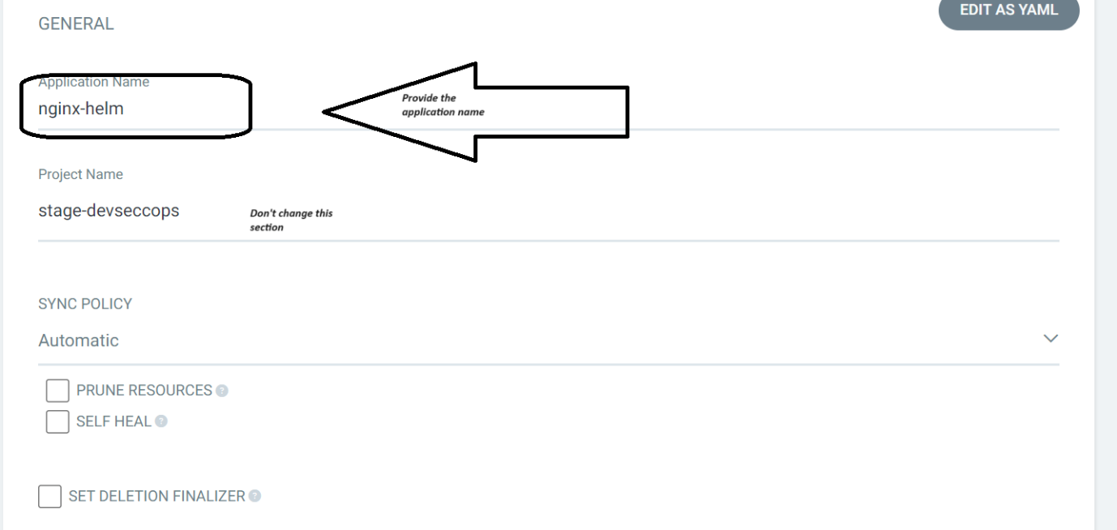

In the sources section select helm

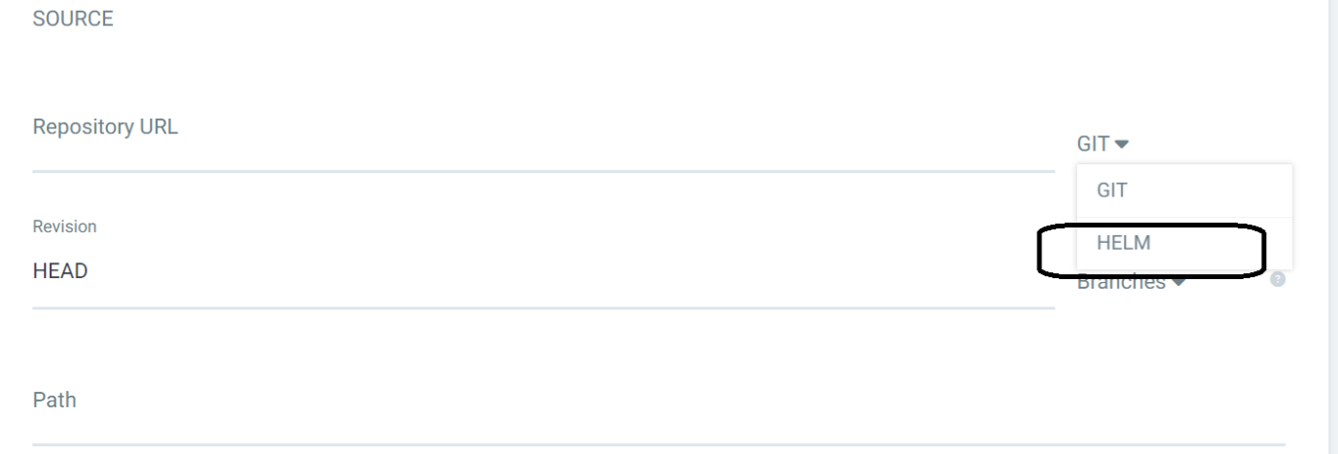

Sources Repository URL <https://charts.bitnami.com/bitnami>

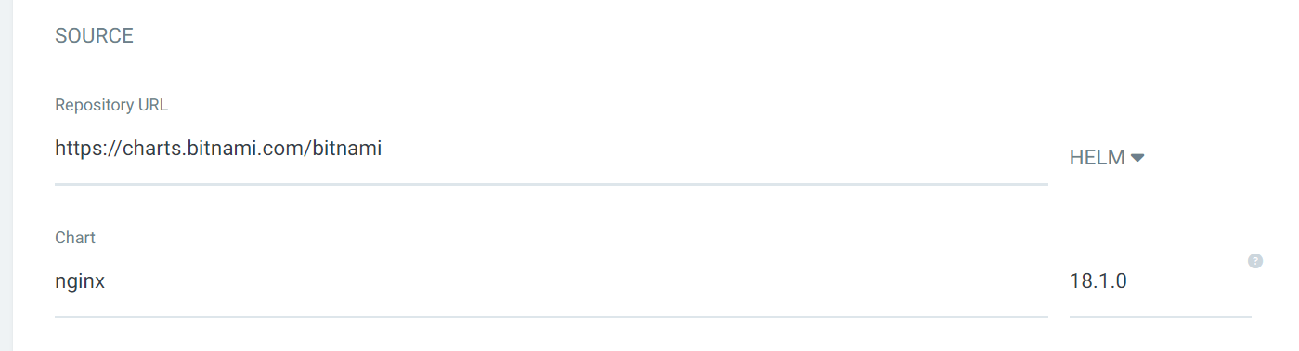

Option to pass values files from helm repo

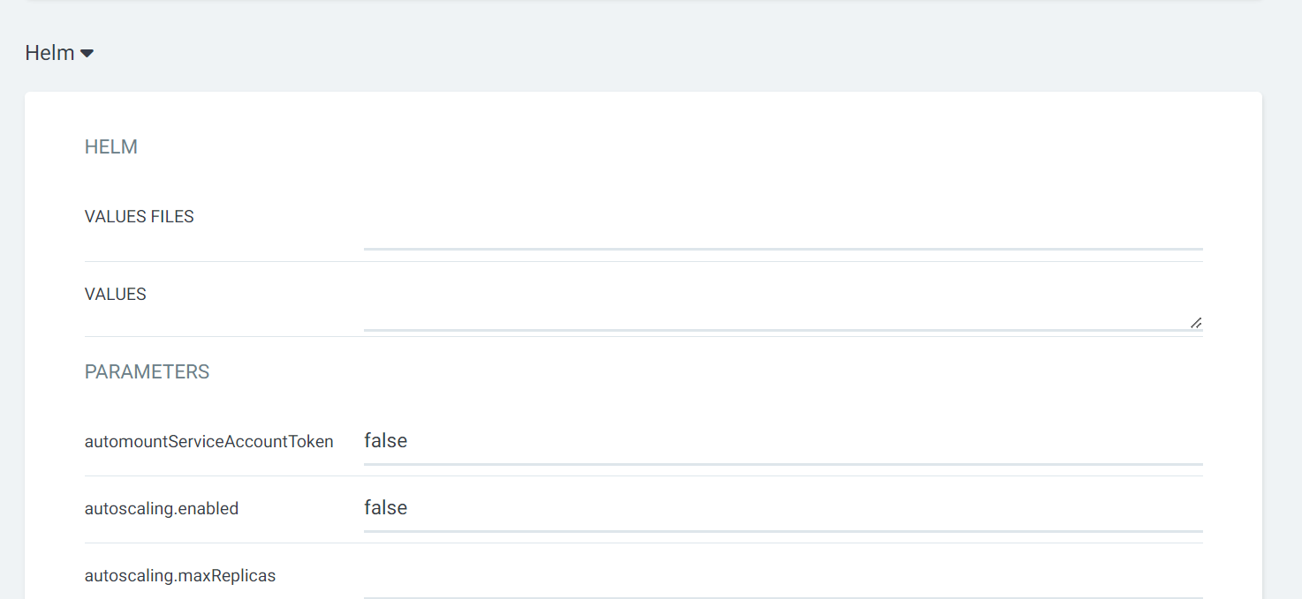

Create the app